South Okanagan

Quality Childcare

OES Licensed Preschool

Parent Handbook

OES Preschool

809 School Ave, Oliver, B.C.

Oliver Elementary School -Preschool: (250) 498-3468 Ext. 5
Miss Lisa: (250) 689-4099

Welcome to OES!

The Preschool is owned by Diane Gludovatz, an ECE and special needs worker with over 25 years of childcare experience and managed by her daughter Lisa Gludovatz. Lisa is a licensed Early Childhood Educator and has many years of experience in working with children in various daycare and preschool settings. The Preschool is a licensed member of the Childcare Resource and Referral program and has access to toys, games, and staff training programs.

Philosophy
We strive to provide your children with a sense of security, safety, and well-being. We provide structure and routines, which help the children to know what is expected of them and what they can expect from others. In doing this, we hope to help the children achieve self-discipline and respect for themselves and others.
Quality care can be achieved through a combination of education, experience, a learning attitude and a love for children. Children’s curiosity, creativity, confidence, and initiative are supported in an atmosphere of warmth and respect. We pride ourselves on working closely with parents to help them achieve the goals they have for their child. We consider it an honor to care for children, and we are committed to doing the very best for your child. We have the firm belief that we can all make the world a better place. This is the basis for all of our policies, and is echoed in all of the daily activities.
Environmentally:
1)Any recyclable containers or materials are recycled.
2)Most projects use recyclable items, such as cereal boxes, egg cartons, cardboard tubes, newspapers, etc. Parents are encouraged to save these and bring them to the program.
3)The children have an outside playtime every day, weather permitting. They are encouraged to learn about the environment and responsible ways to care for it.

Personally:
1)By respecting each other’s feelings and thoughts.
2)The Preschool is a harassment free-zone and no bullying or discrimination will be permitted. We take a zero tolerance stance on name-calling, teasing, physical violence, and ostracism. This also means respecting who we are, regardless of economic status, religion, racial background or origin, skin colour, physical and mental abilities, gender, sexual orientation, or political views, beliefs or opinions.
3)By taking responsibility for our actions and developing a healthy sense of self-esteem.
4) Respecting educators and preschool families personal privacy.
5) By protecting each other`s health, including keeping children home if they are sick.
6) When communicating with staff and/of other preschool families, whether that is in person, over messaging services (including the Preschool app), or through social media, we commit to do so respectfully and professionally including the personal commitments enlisted in 1 through 5 above.

Socially:
1)Discovering the ways in which people’s jobs and services affect the quality of life of others in the community. This could involve field trips, such as to a bakery or fire station.
2)Discovering the ways in which we ourselves can enhance someone else’s life, such as visiting Sunnybank Center and singing for the seniors, and helping with the community garden.
3)Charitable acts. We will be trying to do one fundraiser every few months, which will benefit such charities as the food bank, Christmas Hamper Fund, World Wildlife Fund, etc. The funds may be raised through bake sales, penny carnivals, Halloween party, etc.

Any suggestions or ideas about fundraising, field trips, or ways to encourage the children to be socially responsible are warmly welcomed.

Manager/Caregiver Responsibilities

- To make sure the Preschool and play areas are safe for the children by keeping all dangerous areas, materials, etc. inaccessible to the children, and by using safe toys, materials and equipment.
- To be sure that the Preschool maintains the health and safety of the children by making sure the children get time to play, both indoors and outdoors, adult attention, practicing proper hygiene, and notifying the parents of any health problems or concerns about their children.
- To make sure all children are supervised at all times.
- To call the parents, and if necessary, an ambulance, if their child becomes suddenly ill or injured.
- To be able to handle an injury, emergency or fire in a safe way.
- To make sure that all persons who are volunteering or working within the Preschool setting have completed a Criminal Record Check.
- To make sure that all employees have the appropriate qualifications.
- To make sure that anyone who is to be left alone with the children have a valid first aid certificate.
- To keep confidential, all information received about a child or a child’s family.

Parent responsibilities

- To pick up and drop off their child on time, this is 8:40 and 11:10 or 12:10 and 2:40. Late fees will be applied
- To let the caregiver know if an authorized pickup person will be picking up their child.
- To let the Preschool know if the child will be late or absent, please leave a message on phone, giving the Preschool as much notice as possible.
- To give all information needed, to care for a child by filling in the registration form, completely and accurately.
- To fill in the attendance sheet when picking up or dropping off their child.
- To keep their child home if he/she is ill, and to pick them up as soon as possible if they become ill while in care.
- To let the caregiver know if their child has a communicable disease, or has come in contact with one.
- To make sure their child is dressed appropriately for the weather and for field trips.
- To send an adequate snack.
10. To pay fees or renew subsidy contracts on time.

Hours of Operation, and Closures
We are open Monday to Friday, from 8:40am to 11:10, and 12:10pm to 2:40pm, with the exception of Statutory Holidays and some School Holidays, when we will be closed. We will let you know well in advance of the Preschool closures.

Rates

Preschool fees have a yearly rate as follows:

Mon, Wed, Fri Preschool ~~~~~~~~~~~$2250.00
Tues, Thurs Preschool~~~~~~~~~~~~~$1500.00
Monday to Friday (5 days per week)~~~$3700.00

Preschool can be broken down into monthly payments as follows:

Preschool Prepayment discounted Rates
Mon, Wed, Fri Preschool~~~~~~~~~~ $225.00
Tues, Thurs Preschool~~~~~~~~~~~~$150.00
Monday to Friday (5 days per week)~~$375.00

You will be responsible for pre-paying for the class in which your child is registered. As you are reserving a spot for your child, you will not be reimbursed for any days missed.

No refunds are given for absences due to family Vacations, illness, or legal holidays, or school holidays (such as Christmas, Easter, spring break, or Pro D days etc.

Payments can be made by email money transfer, post dated cheque or cash by the 1st of each month. If paying by cheque, please make them payable to South Okanagan Quality Childcare. If payment is not received by the 5th, you will be assessed a 10% late fee and your child will not be able to attend until your account is up to date. If payment is not received by the 15th, then your child will lose their spot. You will receive a receipt every time you make a payment for your income tax purposes. (Please keep your receipts)

Fees do not include snacks. Please send an adequate snack and water bottle with your child.

In the event you have forgotten a snack, one may be offered. If we give your child a snack, the staff will inform you (the parent) of what was given. It will be written on or above the sign in sheet.

Occasionally we have a special birthday or party. If we are having a special occasion where cake or cookies or other food is served, you will be notified ahead of time. If you do not wish your child to take part in holiday treats, please let us know.

Holding Fees

In the event that your family will need to miss a month of Preschool, you will be required to pay a holding fee of $50.00 per month.

Termination of Care

There is an initial four (4) week trial period in order to determine whether a child can adapt well to this setting. During this period, either party (caregiver or parent) may terminate care without notice. Repayment of any unused days of care will be in full.

After this trial period, two (2) weeks notice is needed for either party to terminate care. If a parent withdraws their child without notice, they are responsible for paying for the next month’s fees. If the facility withdraws the child, repayment will be in full for the remainder of that month and any post dated cheques will be returned.

Graduation

OES Preschool’s end of year Graduation is for the children who will be; turning 5 within that calendar year, and moving on to Kindergarten the following Fall.

Memory Photo Books

OES Preschool provides each student with a memory photo book at the end of the school year. This book is complimentary for the students who have been in attendance for at least 5 consecutive months of the school year, as well as still be an active registration in June of that school year. If your child has not been enrolled for at least 5 months, you may purchase a book at the end of the year. If you would like to request an additional book, you may purchase an extra one. (Prices of the photo books will vary from year to year.)

Pickup

To ensure the safety of your child, only you and people you have authorized on your child’s registration form will be allowed to pick up your child. If for some reason, someone not on this list will be picking up your child, you must let us know beforehand. We cannot release a child to anyone not on the list, even if the child knows who he/she is.

You will need to pick your child up at the Preschool by 11:10am or 2:40pm depending on your class. Please be on time. If you are late, you will be inconveniencing the Preschool’s employee and the next class. It is imperative that you are on time. Therefore, the late policy is rather strict, and is as follows: You will have a 10 minute grace period, after which you will be charged $1.00 for every minute or part thereof that your child is still at Preschool. The time will be determined according to the Preschool’s clock. If it is one half hour past closing time and you are still not here and could not be reached, or have not phoned, then we will call your emergency contacts to come get your child. If we are unable to contact your emergency contacts, we will call The Ministry for Children and Family Development to come pick up your child.

We cannot allow a child to walk home or be sent home in a taxi. Yourself or an authorized pickup person must pick them up. There are no exceptions for this.

Pick up must be by an adult 19 years or older

If a parent or guardian is under the influence of drugs or alcohol when coming to pick up their child, we will offer to call a taxi or help the impaired person to find a designated driver in order to get the child and adult home safely. If the parent/guardian insists on driving home, we are legally obligated to phone the police with the description of the vehicle, license plate number, direction of travel, and also phone the Ministry for Children and Family Development. We will not allow an impaired authorized pick up person, other than the parent, to pick up a child.

Legally, we cannot stop a parent with legal guardianship from picking up their child.

Parental Access

Please note that we have an “Open Door” policy. This does not mean that our doors are left open at all times. This simply means that you are welcome to come visit your child at anytime during Preschool hours. Feel free to stop by. *COVID-19 Restrictions may affect this policy*

Confidentiality

Any information about your family will be kept confidential, unless it involves suspected abuse of the child.
Legally, we are required to report to the Ministry for Child and Family Development if there are signs that a child is being neglected or abused. This could include:
-signs of physical abuse, such as unexplained injuries, presence of several injuries in different stages of healing, repeated injuries and/or accidents
-signs of sexual abuse, such as fatigue due to sleep disturbances, self-mutilation, difficulty walking, excessive itching in the genital area, disclosure
-signs of neglect, such as unattended medical needs, consistent lack of supervision, consistent hunger, poor hygiene, persistent conditions, developmental delays.
There are also behavioral indicators for each of these. The Preschool has The B.C. Handbook for Action on Child Abuse and Neglect and all staff will abide by it to the letter.

Discipline Policy

Our discipline policy is preventative and we use positive guidance strategies. We let the children know exactly what we expect from them in each situation, as well as the consequences for not meeting expectations. This allows the children to be responsible for their actions. Consequences are non-physical, and range from diversion and redirection to removal from an activity. Positive reinforcement is used for appropriate actions, and the discipline and guidance is adapted to fit each individual child, to help them develop self-control while maintaining healthy self esteem.

If you would like to know more about our Guidance and discipline or behavior management policy, please feel free to ask for a copy of our Guidance and discipline handbook.

Emergency Procedures

Fire drills are practiced monthly. In case of fire our meeting place is at the North East picnic tables, and then we walk down one block to Jen Jensen’s house at 456 School avenue and call parents.

If there is an emergency evacuation of the entire area, we will then call Emergency back up adults for transport and proceed by car 44 kms to Interior Health in Penticton on Carmi Avenue. (If parents are unable to pick up right away.) Corner of Carmi and Government street.

If there is a disruption of basic services and the children are unable to be cared for adequately, then parents will be called to come pick up their children.

In the unlikely event that we are unable to leave the building due to an extended lockdown or some other emergency, we ask that each parent write a short letter to their child to help support and ease the anxiety this may cause your child. We know that this is highly unlikely but licensing requires us to be prepared. Please enclose a family photo with your letter for us to put in our Emergency Supplies Kit.

Screen Time Policy
Generally there is no screen time at Preschool, with the exception of occasional short (special 15 minutes or less) educational presentations. The teacher will use either her laptop or tablet for these purposes. Your children are only with us for 3 hours, and in that time are much too busy to be looking at a screen.

Sickness

There is an illness policy at the end of this manual, which has been supplied by the health unit. As a licensed facility, we have chosen to abide by it. If your child becomes ill in our care, we will call you to come pick up your child. If your child becomes suddenly ill or injured, first aid will be administered, and an ambulance will be called if necessary.
If your child has a communicable disease, or has come in contact with one, please let us know, so we can alert the Public Health Nurse and Licensing. Please let us know if your child has had any major life changes, as this often translates into stomach aches or other physical symptoms, as well as behavioral changes.

Emergency management of Pandemic influenza or Covid-19

During a pandemic if we are open, our centre will enforce strict cleaning, attendance and capacity rules.
Capacity – maximum 10 children in order to comply with social distancing measures to the best of our ability. Outside as much as possible and during pick up and drop off.
Attendance – All parents must take their childs temperature each day and sign a declaration that they ensure that their child is not sick or been exposed to anyone who is. (see covid wellness declaration)
**DONOT bring your child if they or you are sick**
Cleaning – All toys and high touch areas are cleaned daily
Parents and children will be required to use hand sanitizer at drop off each day. In addition to regular hand washing before eating and after toileting, Children will be required to wash their hands if they cough, sneeze or put anything in their mouths. Any toys that are mouthed will be sanitized immediately as well as any areas that may have been coughed or sneezed on.
If a child becomes sick at preschool the parent or emergency contact will be called for immediate pick up. The child will be isolated (with a teacher) and required to wear a mask until picked up. All parents will be notified that a child became sick and will be asked to monitor their child for symptoms. The sick childs family will be asked to test for covid and follow public health guidelines.

If a staff member should become sick and tests positive for Covid-19 then they will be required to follow public health guidelines.

Our Preschool does periodic lice checks. Although it’s not a health risk, lice are highly contagious and any child found with lice will be sent home. If your child has lice, you will be notified and you must arrange to have your child picked up. The child may not attend until hair has been treated and all nits are removed. Nits are hard to see, so don’t be offended if we find more and send your child home. Suggestions on treatment and identification of lice and nits can be found online.

Smoking
The School is a non-smoking premises and all people are asked to put their cigarettes out before even entering the School grounds. This way the children are not exposed to second-hand smoke or to the idea that smoking is an acceptable and healthy activity.

Active Play Policy
Our Preschool will ensure a minimum of 30 minutes per day of outdoor active play (indoor active play is acceptable when weather is poor)

Field Trips
Our Preschool understands the value of practical learning. This is why we like to provide the opportunity to visit the places we learn about.
All field trips are parent or responsible adult participation required.

Nutritional Needs

You, the parent, will be responsible for sending a nutritious snack for your children. Please try to send items that are based on the Canada Food Guide (Food Flair), instead of items that are high in sugar or that will not give them enough energy to keep them going until pickup time.

It is the parent’s responsibility to provide an adequate and nutritious snack, it is the child’s responsibility to choose from it and decide how much they eat.

Hand washing, with running water and soap, is used before and after eating, as well as after using the washroom.

The children are encouraged to develop good personal hygiene, which will keep illness in the program at a minimum.

Potty Training

All children must be potty trained before they can attend Preschool.

Preschool Flow of the Day
(Times may vary)

Morning Class:
8:40am ~~~~~~~~~~~~~~~~~~~~~~Welcome
8:40am – 9:10am ~~~~~~~~~~~~~ Outside Play
9:10am – 9:20am ~~~~~~~~~~~~~ Clean up / Go Inside
9:20am – 9:45am ~~~~~~~~~~~~~ Circle
9:45am – 10:15am ~~~~~~~~~~~~~ Art
10:15am – 10:45am ~~~~~~~~~~~~~ Play
10:45am – 11:00am ~~~~~~~~~~~~~ Snack
11:00am – 11:10am ~~~~~~~~~~~~~~ Pack up
11:10am ~~~~~~~~~~~~~~~~~~~~~~ Home Time

Afternoon Class:
12:10pm ~~~~~~~~~~~~~~~~~~~~~~ Welcome
12:10pm – 12:40pm ~~~~~~~~~~~~~~ Outside Play
12:40pm – 12:50pm ~~~~~~~~~~~~~ Clean up / Go Inside
12:50pm – 1:15pm ~~~~~~~~~~~~~~~ Circle
1:15pm – 1:45pm ~~~~~~~~~~~~~~~~ Art
1:45pm – 2:15pm ~~~~~~~~~~~~~~~ Play
2:15pm – 2:30pm ~~~~~~~~~~~~~~~ Snack
2:30pm – 2:40pm ~~~~~~~~~~~~~~ Pack up
2:40pm ~~~~~~~~~~~~~~~~~~~~~ ~ Home Time

This PhUnknown Author is licensed under CCY
This PhUnknown Author is licensed under CCY
South Okanagan Quality Childcare
OES Preschool
809 School Avenue, Oliver, BC V0H 1T0
OES: 250-498-3468 Ext # 5 OR Proprietor Diane Gludovatz: 250-485-8041
--------------------------------------------------------------------------------------------------------------------
Symptom | May return when
Temperature of 100 F / 37.8 C or higher (orally) or 99 F / 37.2 C or higher (under the arm) | May return to our program when symptom free, without help from medications, for 24 hours.
Cough | May return to our program when symptom free, without help from medications, for 24 hours.
Sore throat | May return to our program when symptom free, without help from medications, for 24 hours.
Difficulty breathing or wheezing | May return to our program when symptom free, without help from medications, for 24 hours.
Unexplained fatigue, aches or cold/flu-like symptoms | May return to our program when symptom free, without help from medications, for 24 hours.
Children who have, or children with others living in the same home who are showing symptoms/ have tested positive for COVID-19 | May return to our program after following current Public Health Guidelines

(Reference: Health Authority memo; COVID19 in childcare)

Additionally, our regular health and wellness policy stands:

Children may not attend child care programs while they have any of the following symptoms:
- unusual, unexplained loss of appetite, fatigue, irritability, or headache
- eye infections
- unexplained rashes or any rash that is not confirmed by doctor to be non-contagious
- known or suspected communicable diseases (measles, chicken pox, pink eye, hand foot and mouth, etc)
- ear infection
- nausea, vomiting and/or diarrhea in the last 48 hours

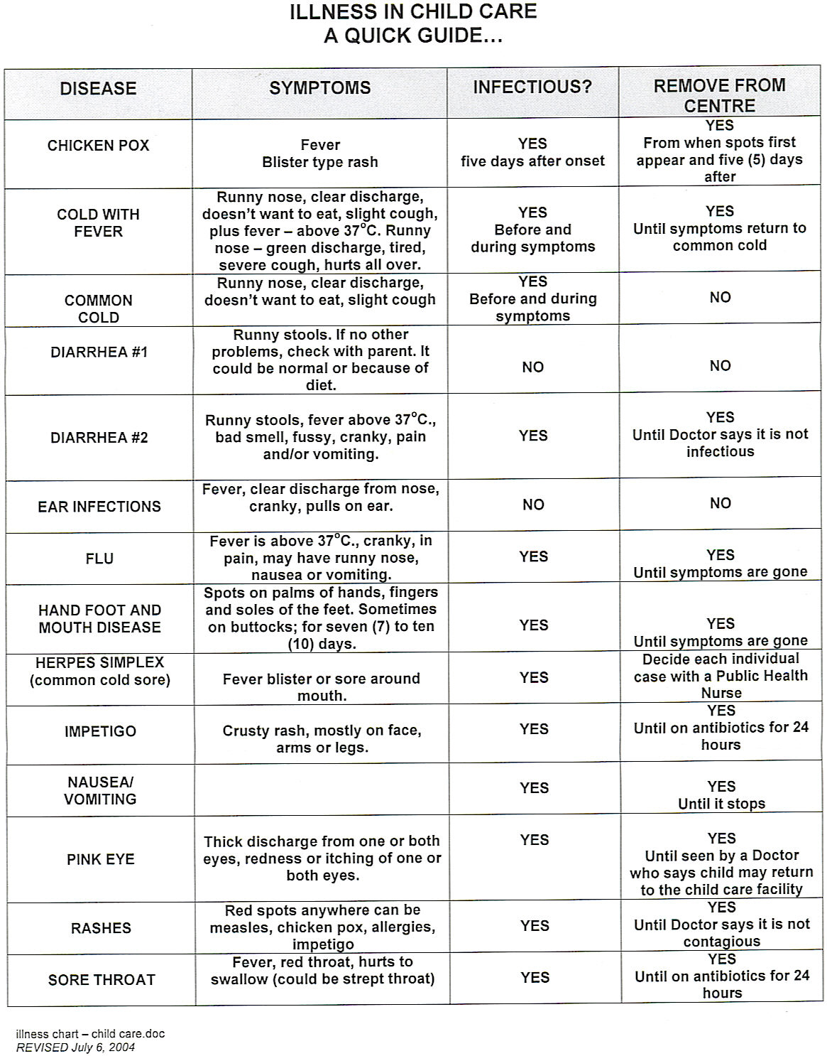

Please keep this form in an easily accessible area for reference and viewing.

